1:if else statement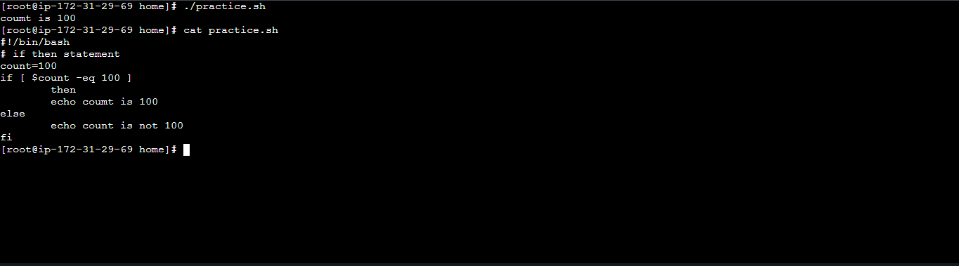
2:finding a file exist or not:
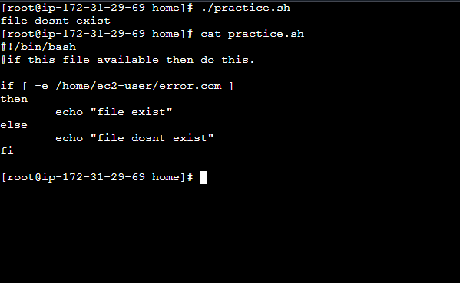
3:case statement:

